**Govind Singh (1BM23CS102)**

***in partial fulfillment for the award of the degree of***

**BACHELOR OF ENGINEERING**

***in***

**COMPUTER SCIENCE AND ENGINEERING**



**B.M.S. COLLEGE OF ENGINEERING**

**(Autonomous Institution under VTU)**

**BENGALURU-560019**

**Aug-2025 to Dec-2025**

**.**

**VISVESVARAYA TECHNOLOGICAL**

**UNIVERSITY**

**“JnanaSangama”, Belgaum -590014, Karnataka**



**LAB RECORD**

**Bio Inspired Systems (23CS5BSBIS)**

***Submitted by***

Dr. Raghvendra CK

**B.M.S. College of**

who is a Bonafide student of

Visvesvaraya

has been approved as it satisfies the academic requirements of the above-mentioned subject and

the work prescribed for the said degree.

Technological University, Belgaum. The Lab report

Dr. Kavitha Sooda

Assistant Professor

Professor & HOD

Department of CSE, BMSCE

Department of CSE, BMSCE

This is to certify that the Lab work entitled “Bio Inspired Systems (23CS5BSBIS)” carried out

**B.M.S. College of Engineering,**

**Bull Temple Road, Bangalore 560019**

(Affiliated To Visvesvaraya Technological University, Belgaum)

**Department of Computer Science and Engineering**



**CERTIFICATE**

**Govind Singh (1BM23CS102),**

by

**Engineering.**

**Bachelor of Engineering in Computer**

It is in partial fulfillment for the award of

**Science and Engineering**

of the

https://github.com/GovindSingh-95/BIS-Lab-Session.git

6

7

22

Parallel cellular algorithm

13/10/2025

18

Grey wolf optimizer

29/9/2025

5

16

Cuckoo search algorithm

15/9/2025

Github Link:

18/8/2025

**No.**

**Page No.**

**Experiment Title**

**Date**

**Sl.**

**Index**

4

14

Ant Colony Optimization

8/9/2025

3

11

Particle Swarm Optimization

1/9/2025

2

6

Optimization via gene expression

25/8/2025

1

4

Genetic Algorithm

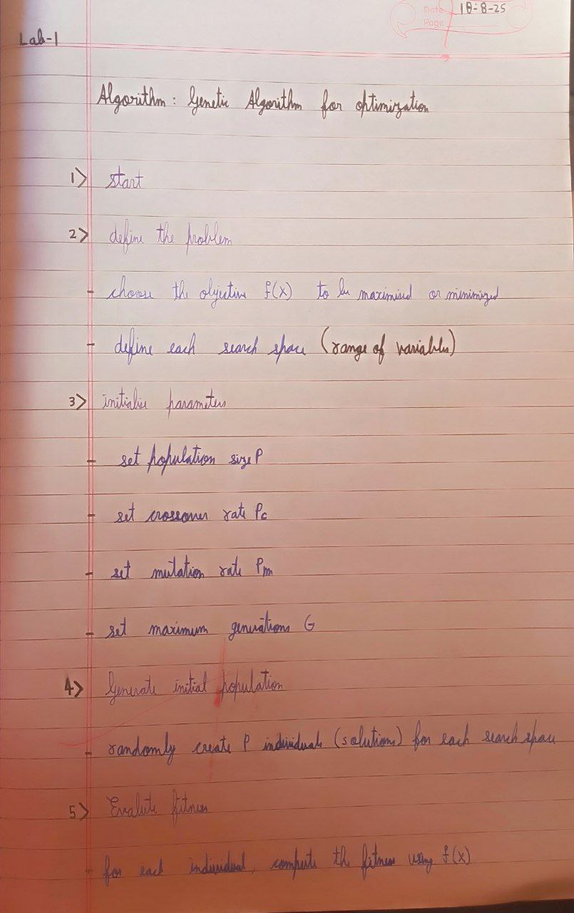

**Algorithm:**

for solving optimization and search problems.

fittest individuals are selected for reproduction to produce the next generation. GAs are widely used

Genetic Algorithms (GA) are inspired by the process of natural selection and genetics, where the

**Problem statement:**

**Program 1 : Genetic Algorithm**

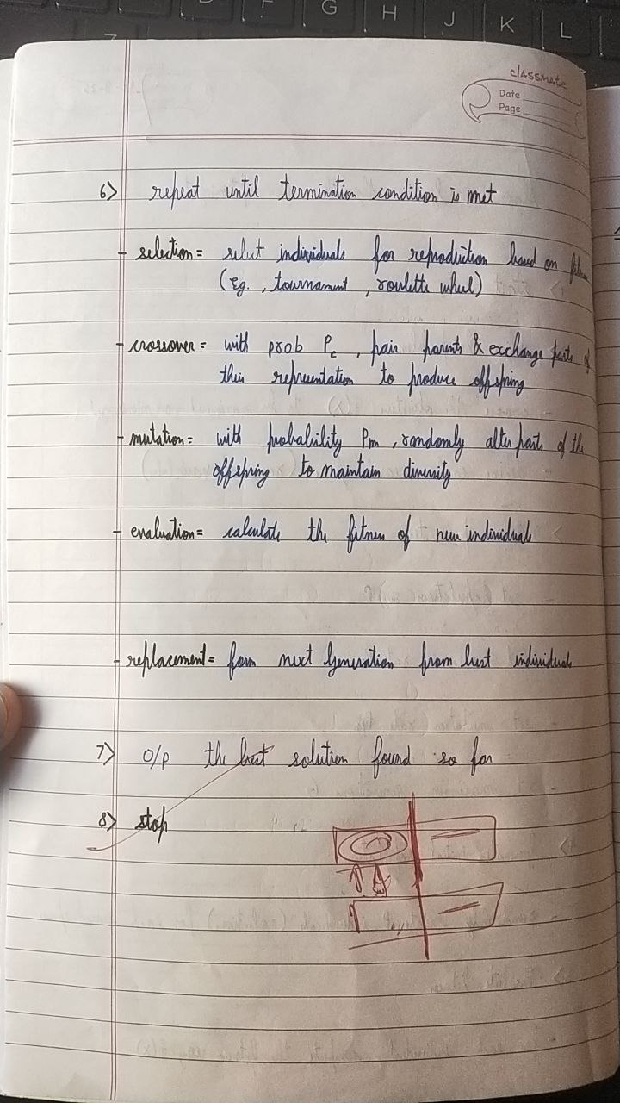

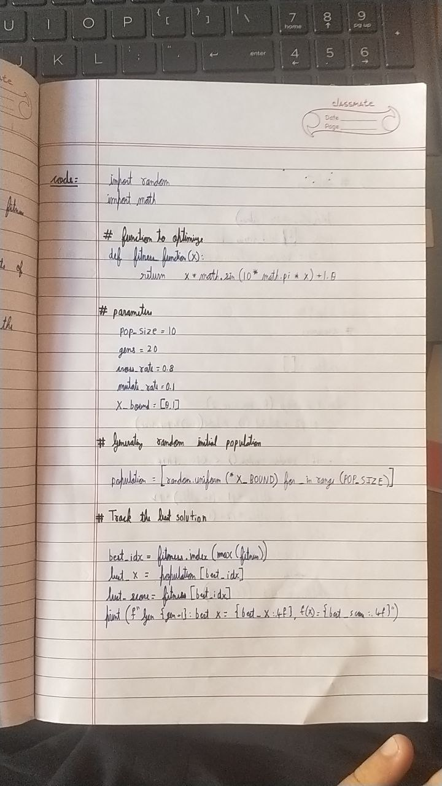

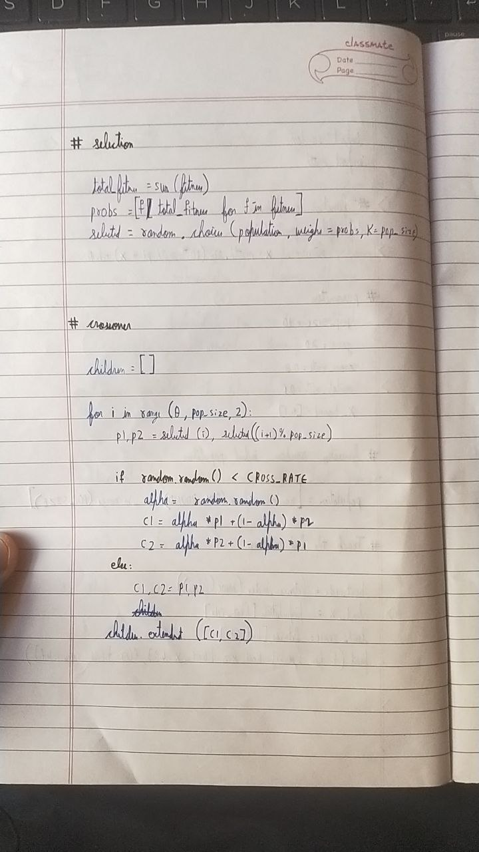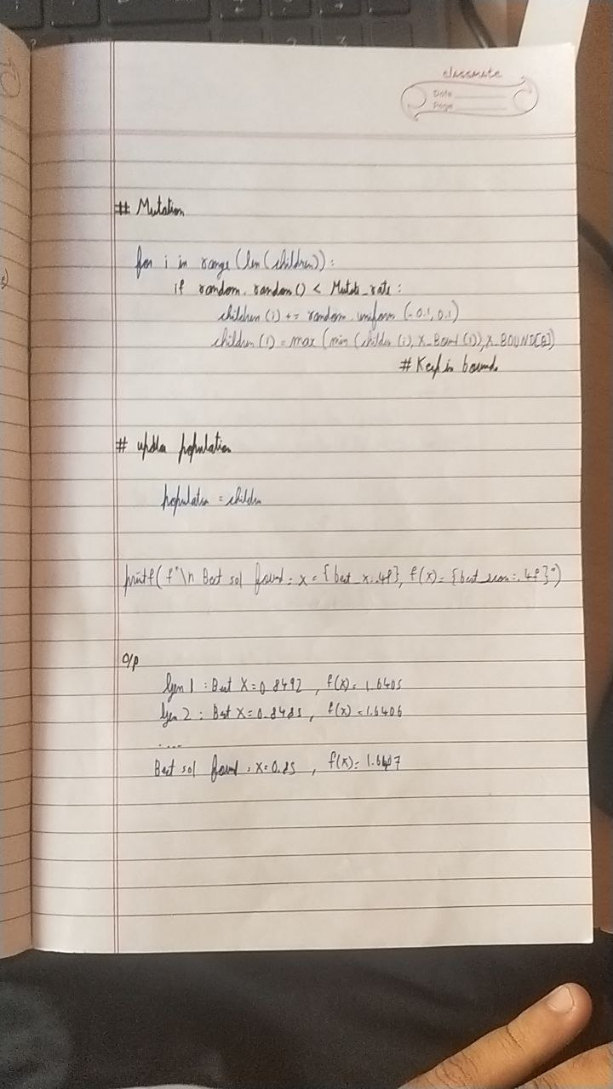

return selected[0]

def genetic_algorithm(initial_population=None, pop_size=6, generations=20, crossover_rate=0.8,

return x

return bin_to_int("".join(b))

b[pos] = '1' if b[pos] == '0' else '0'

pos = random.randint(0, 4)

b = list(int_to_bin(x))

if random.random() < mutation_rate:

def mutate(x, mutation_rate=0.1):

return child1, child2

child2 = bin_to_int(b2[:point] + b1[point:])

child1 = bin_to_int(b1[:point] + b2[point:])

point = random.randint(1, 4)

b1, b2 = int_to_bin(p1), int_to_bin(p2)

def crossover(p1, p2):

selected.sort(key=lambda x: fitness(x), reverse=True)

selected = random.sample(pop, k)

def tournament_selection(pop, k=3):

return int(b, 2)

def bin_to_int(b):

return format(x, '05b')

def int_to_bin(x):

return x**2

def fitness(x):

import random

**Code:**

**Problem statement:**

population = new_pop[:pop_size]

population.sort(key=lambda x: fitness(x), reverse=True)

best = population[0]

print(f"\nBest Solution: x={best}, f(x)={fitness(best)}")

custom_population = [3, 7, 15, 20, 25, 30]

genetic_algorithm(initial_population=custom_population, generations=5)

**Program 2 : Optimization via Gene expression**

new_pop.extend([child1, child2])

Gene Expression Algorithms (GEA) are inspired by the biological process of gene expression in

living organisms. This process involves the translation of genetic information encoded in DNA into

functional proteins. In GEA, solutions to optimization problems are encoded in a manner similar to

genetic sequences. The algorithm evolves these solutions through selection, crossover, mutation, and

gene expression to find optimal or near-optimal solutions. GEA is effective for solving complex

optimization problems in various domains, including engineering, data analysis, and machine

learning.

**Algorithm:**

new_pop = [best]

mutation_rate=0.1):

if initial_population:

population = initial_population[:pop_size] # take only needed size

else:

population = [random.randint(0, 31) for _ in range(pop_size)]

for gen in range(generations):

population.sort(key=lambda x: fitness(x), reverse=True)

best = population[0]

print(f"Gen {gen}: Best x={best}, f(x)={fitness(best)}")

while len(new_pop) < pop_size:

parent1 = tournament_selection(population)

parent2 = tournament_selection(population)

if random.random() < crossover_rate:

child1, child2 = crossover(parent1, parent2)

else:

child1, child2 = parent1, parent2

child1 = mutate(child1, mutation_rate)

child2 = mutate(child2, mutation_rate)

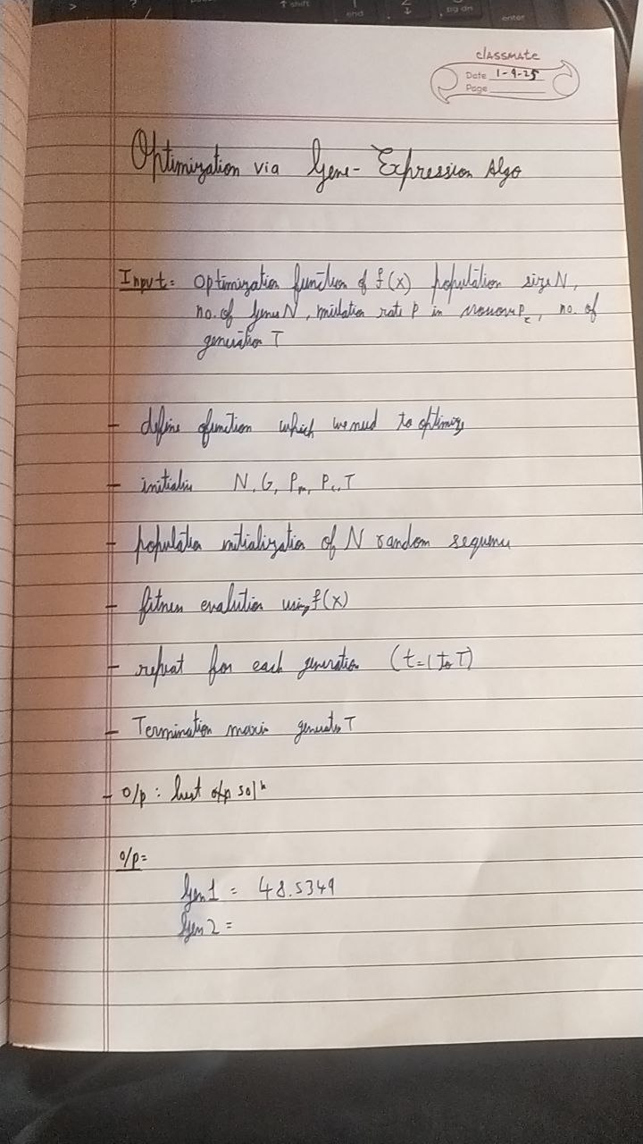

**Code:**

import random

import math

cities = [

(0, 0), (1, 5), (5, 2), (6, 6), (8, 3),

(2, 1), (7, 7), (3, 3), (4, 4), (9, 0)

]

def distance(a, b):

return math.sqrt((a[0]-b[0])**2 + (a[1]-b[1])**2)

def total_distance(tour):

dist = 0

best = scored[0][0]

p2_index += 1

child[i] = parent2[p2_index]

return child

def genetic_algorithm(generations=100, pop_size=100, mutation_rate=0.1):

num_cities = len(cities)

population = [create_individual(num_cities) for _ in range(pop_size)]

best = None

best_dist = float('inf')

for gen in range(generations):

scored = [(ind, total_distance(ind)) for ind in population]

scored.sort(key=lambda x: x[1])

if scored[0][1] < best_dist:

while parent2[p2_index] in child:

best_dist = scored[0][1]

new_pop = [best]

while len(new_pop) < pop_size:

p1 = random.choice(scored[:50])[0]

p2 = random.choice(scored[:50])[0]

child = crossover(p1, p2)

child = mutate(child, mutation_rate)

new_pop.append(child)

population = new_pop

if gen % 20 == 0:

print(f"Gen {gen}: Best distance = {best_dist:.2f}")

if random.random() < rate:

for i in range(len(tour)):

city_a = cities[tour[i]]

city_b = cities[tour[(i+1) % len(tour)]]

dist += distance(city_a, city_b)

return dist

def create_individual(n):

gene = list(range(n))

random.shuffle(gene)

return gene

def mutate(individual, rate=0.1):

ind = individual[:]

for i in range(len(ind)):

j = random.randint(0, len(ind)-1)

ind[i], ind[j] = ind[j], ind[i]

return ind

def crossover(parent1, parent2):

size = len(parent1)

a, b = sorted([random.randint(0, size-1) for _ in range(2)])

child = [None]*size

child[a:b+1] = parent1[a:b+1]

p2_index = 0

for i in range(size):

if child[i] is None:

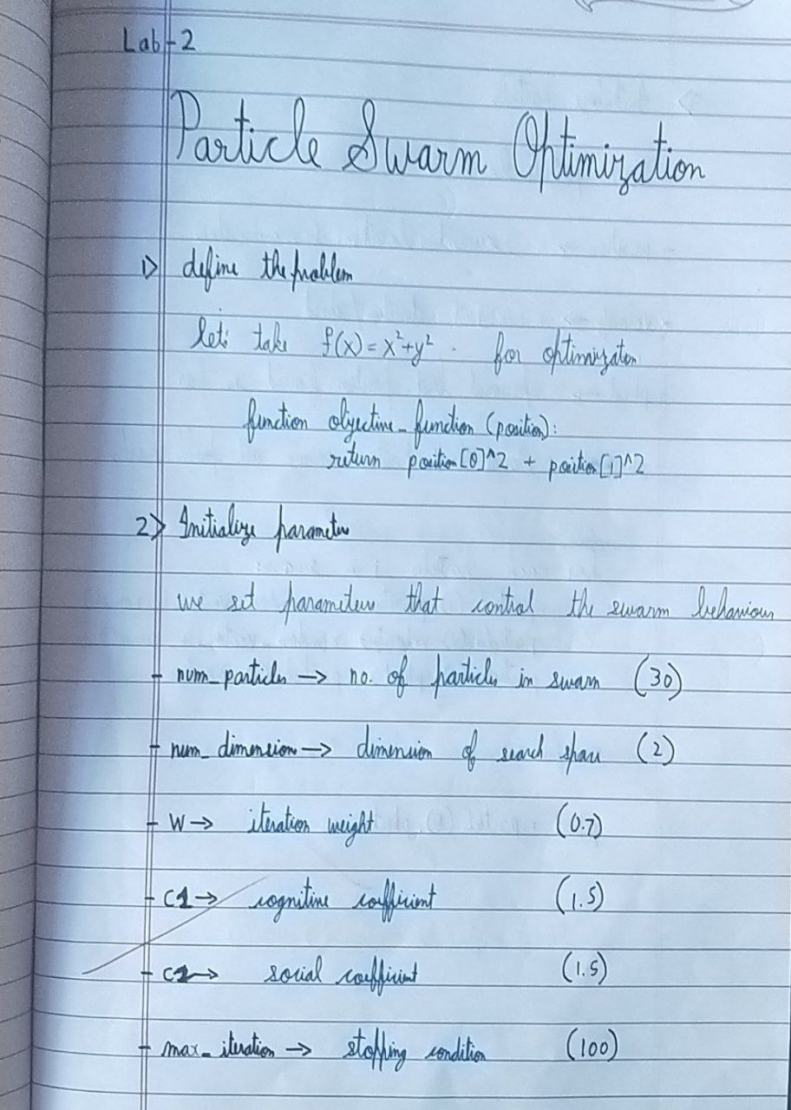

**Algorithm:**

regard to a given measure of quality.

schooling. PSO is used to find optimal solutions by iteratively improving a candidate solution with

Particle Swarm Optimization (PSO) is inspired by the social behavior of birds flocking or fish

**Problem statement:**

**Program 3 : Particle swarm Optimization**

print(f"Total distance: {best_dist:.2f}")

print(best_tour)

print("\nBest tour found:")

best_tour, best_dist = genetic_algorithm()

return best, best_dist

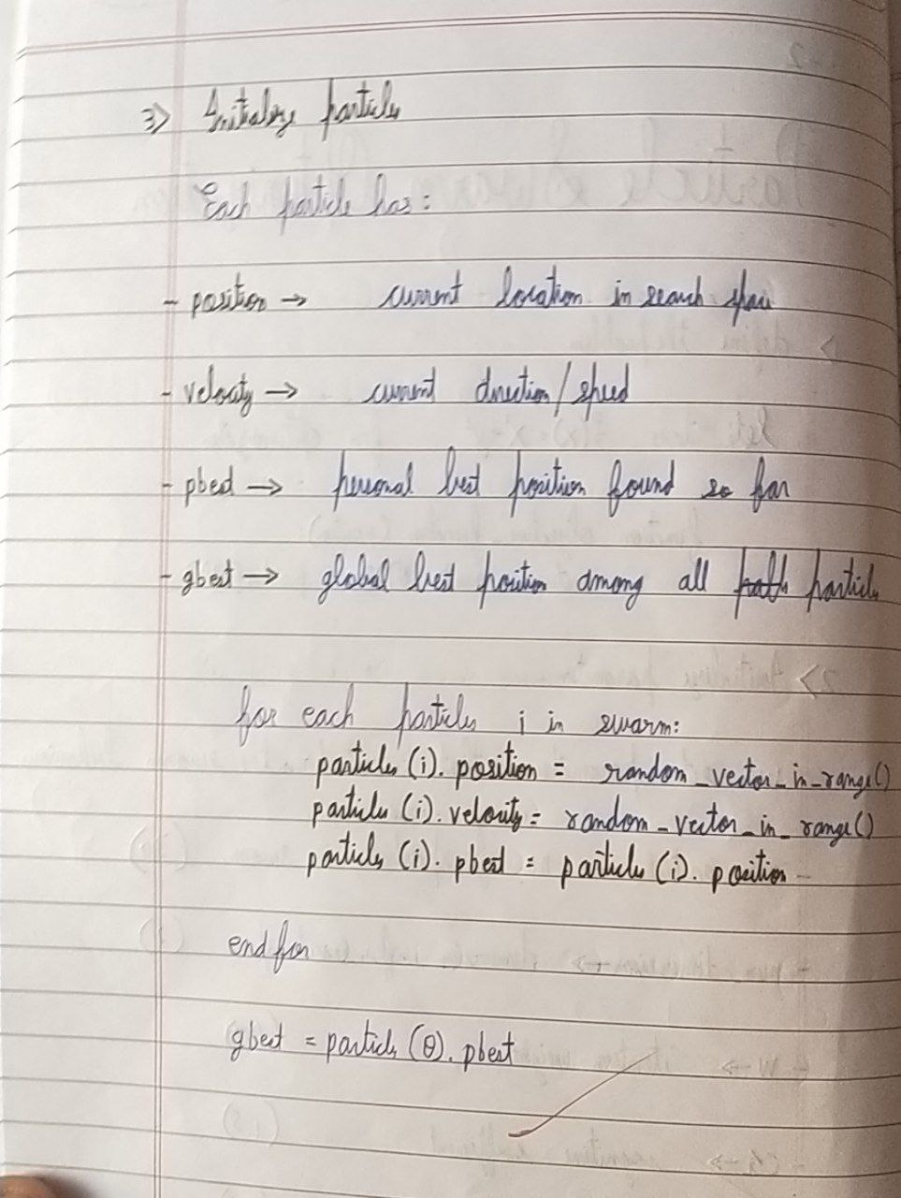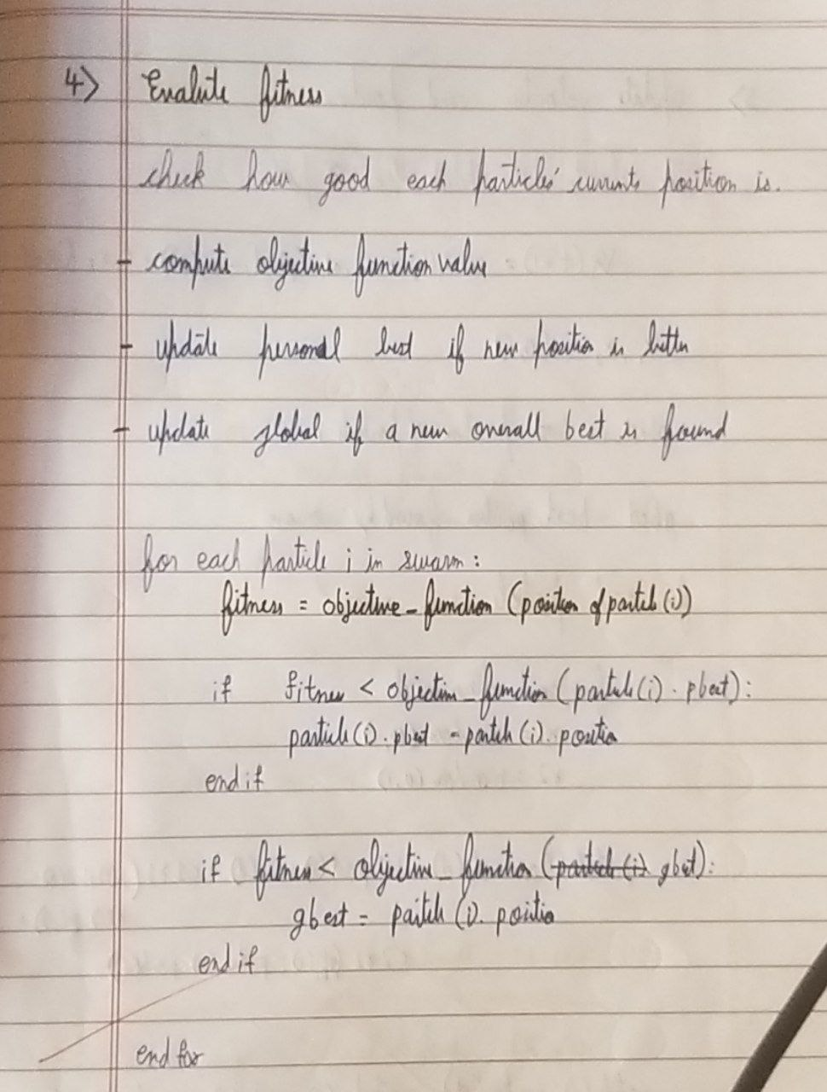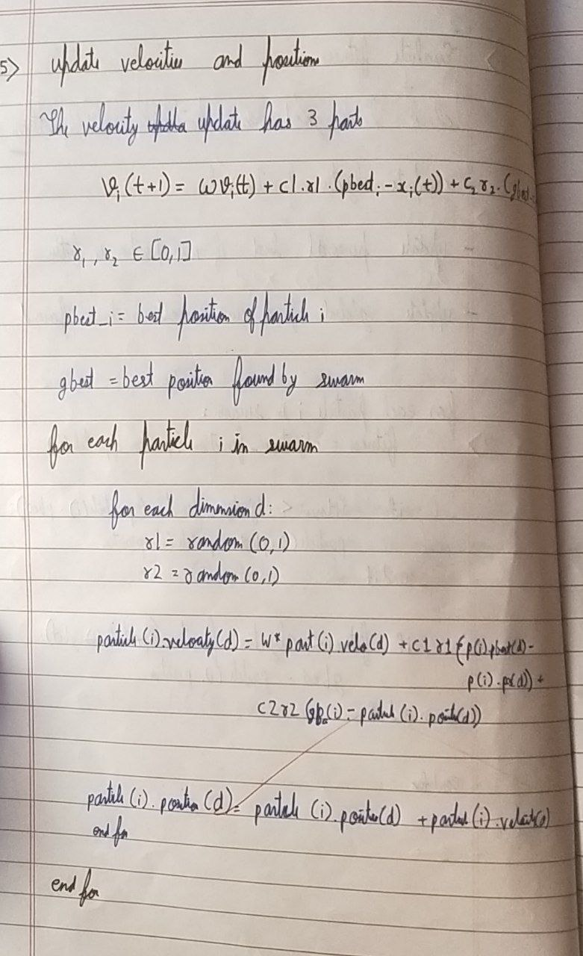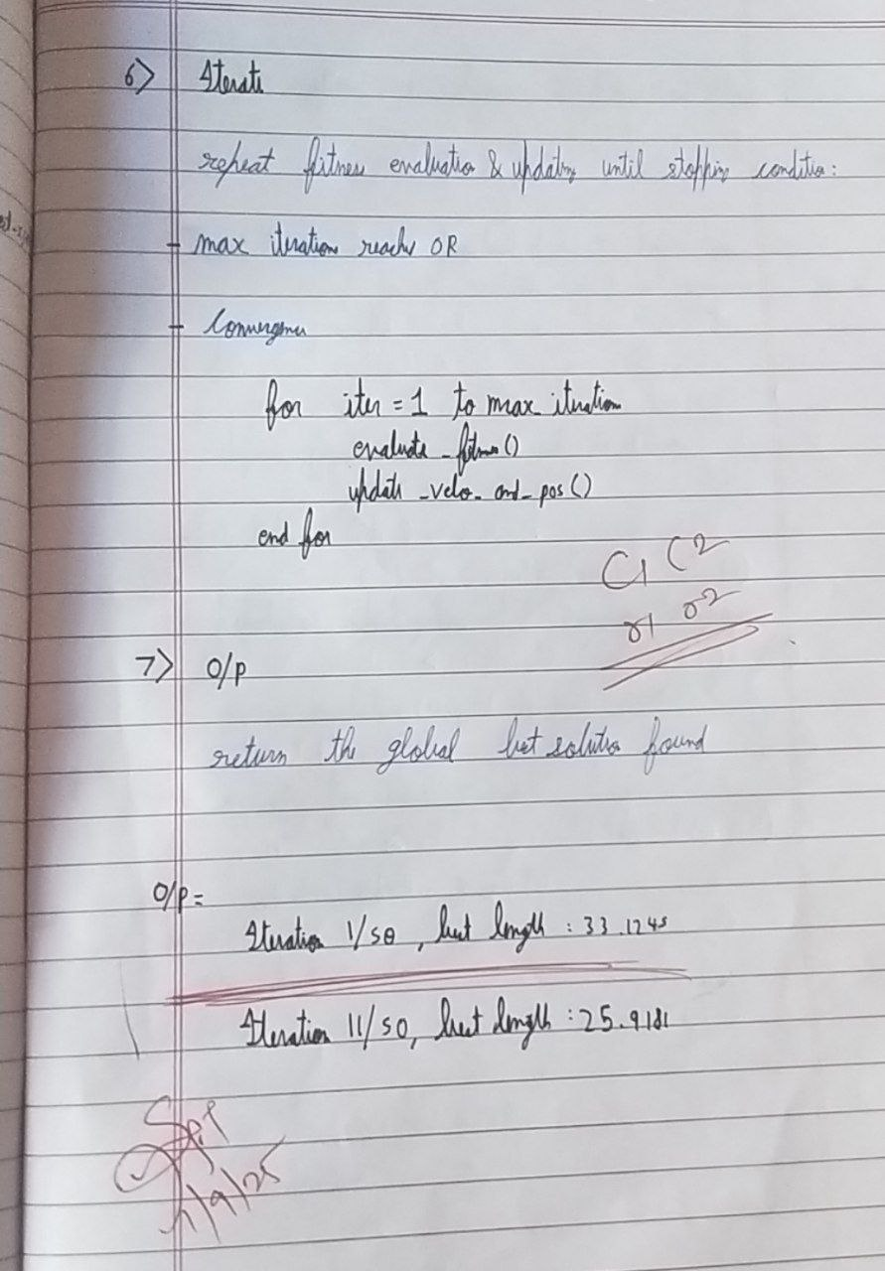

theta_0, theta_1 = theta

c2 = 2.1

c1 = 1.5

w = 0.7

num_iterations = 10

num_particles = 30

return np.sum(errors**2)

errors = y_data - predictions

predictions = theta_0 + theta_1 * x_data

def objective_function(theta):

y_data = np.array([3, 5, 7, 9, 11])

x_data = np.array([1, 2, 3, 4, 5])

import numpy as np

**Code:**

**Program 4 : Ant Colony Optimization**

velocities[i] = w * velocities[i] + cognitive + social

positions[i] += velocities[i]

for dim in range(2):

positions[i, dim] = np.clip(positions[i, dim], bounds[dim][0], bounds[dim][1])

print(f"Iteration {iteration+1}/{num_iterations}, Best SSE: {global_best_value:.5f}")

print("\nBest parameters found:")

print("theta_0 =", global_best_position[0])

print("theta_1 =", global_best_position[1])

print("Minimum sum of squared errors:", global_best_value)

social = c2 * r2 * (global_best_position - positions[i])

**Problem statement:**

The foraging behavior of ants has inspired the development of optimization algorithms that can solve

complex problems such as the Traveling Salesman Problem (TSP). Ant Colony Optimization (ACO)

simulates the way ants find the shortest path between food sources and their nest. Implement the

ACO algorithm using Python to solve the TSP, where the objective is to find the shortest possible

route that visits a list of cities and returns to the origin city.

**Algorithm:**

fitness = objective_function(positions[i])

bounds = [(-10, 10), (-10, 10)]

positions = np.array([np.random.uniform(low, high, num_particles) for low, high in bounds]).T

velocities = np.random.uniform(-1, 1, (num_particles, 2))

personal_best_positions = np.copy(positions)

personal_best_values = np.array([objective_function(p) for p in personal_best_positions])

best_particle_index = np.argmin(personal_best_values)

global_best_position = personal_best_positions[best_particle_index]

global_best_value = personal_best_values[best_particle_index]

for iteration in range(num_iterations):

for i in range(num_particles):

if fitness < personal_best_values[i]:

personal_best_values[i] = fitness

personal_best_positions[i] = positions[i]

if fitness < global_best_value:

global_best_value = fitness

global_best_position = positions[i]

for i in range(num_particles):

r1 = np.random.rand(2)

r2 = np.random.rand(2)

cognitive = c1 * r1 * (personal_best_positions[i] - positions[i])

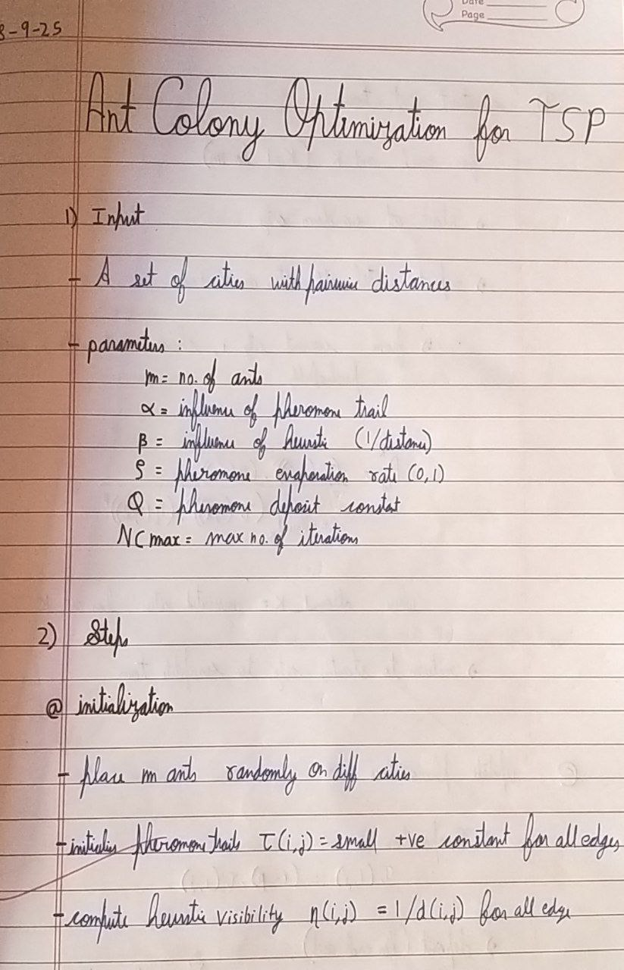

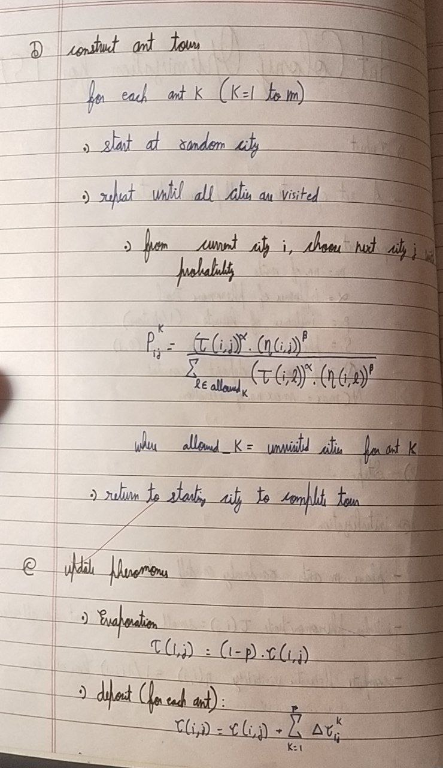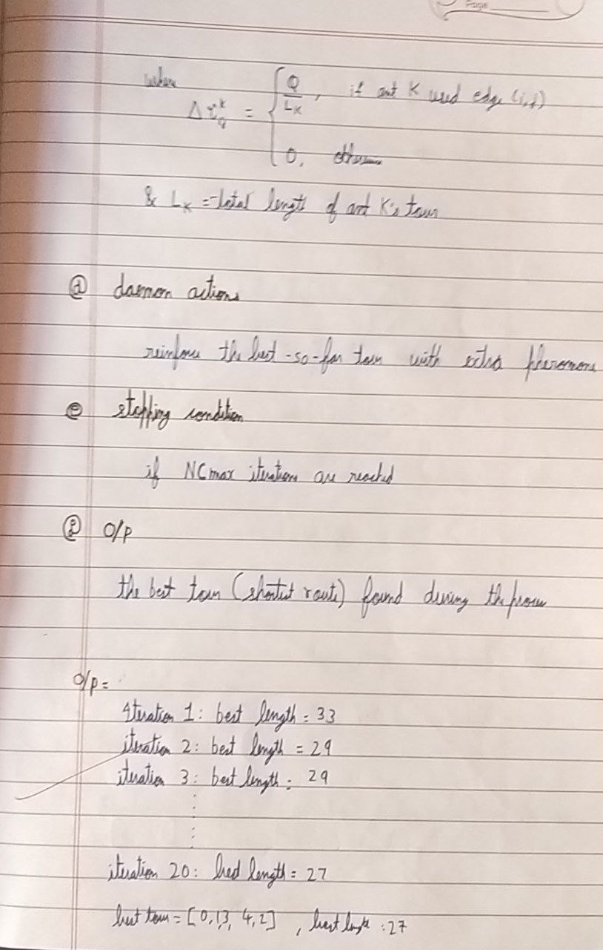

NUM_ITERATIONS = 100

pheromone = np.ones((NUM_CITIES, NUM_CITIES))

dist_matrix = np.sqrt(((cities[:, np.newaxis, :] - cities[np.newaxis, :, :]) ** 2).sum(axis=2))

cities = np.random.rand(NUM_CITIES, 2) * 100

np.random.seed(42)

Q = 100

EVAPORATION = 0.5

BETA = 5.0

ALPHA = 1.0

NUM_ANTS = 20

NUM_CITIES = 10

import random

import numpy as np

**Code:**

print("\nBest Path Found:")

if distance < best_distance:

best_distance = distance

best_path = path

pheromone *= (1 - EVAPORATION)

for i in range(NUM_ANTS):

for j in range(NUM_CITIES):

from_city = all_paths[i][j]

to_city = all_paths[i][j + 1]

pheromone[from_city][to_city] += Q / all_distances[i]

pheromone[to_city][from_city] += Q / all_distances[i]

if iteration % 10 == 0 or iteration == NUM_ITERATIONS - 1:

print(f"Iteration {iteration}: Best Distance = {best_distance:.2f}")

all_distances.append(distance)

print(" -> ".join(map(str, best_path)))

print(f"Total Distance: {best_distance:.2f}")

**Program 5 : Cuckoo search Optimization**

**Problem statement:**

Cuckoo Search (CS) is a nature-inspired optimization algorithm based on the brood parasitism of

some cuckoo species. This behavior involves laying eggs in the nests of other birds, leading to the

optimization of survival strategies. CS uses Lévy flights to generate new solutions, promoting global

search capabilities and avoiding local minima. The algorithm is widely used for solving continuous

tau = pheromone[current_city][next_city] ** ALPHA

best_distance = float('inf')

best_path = []

for iteration in range(NUM_ITERATIONS):

all_paths = []

all_distances = []

for ant in range(NUM_ANTS):

path = [random.randint(0, NUM_CITIES - 1)]

while len(path) < NUM_CITIES:

current_city = path[-1]

probabilities = []

for next_city in range(NUM_CITIES):

if next_city not in path:

eta = (1 / dist_matrix[current_city][next_city]) ** BETA

probabilities.append(tau * eta)

else:

probabilities.append(0)

probabilities = np.array(probabilities)

probabilities /= probabilities.sum()

next_city = np.random.choice(range(NUM_CITIES), p=probabilities)

path.append(next_city)

path.append(path[0]) # Return to starting city

distance = sum(dist_matrix[path[i]][path[i + 1]] for i in range(NUM_CITIES))

all_paths.append(path)

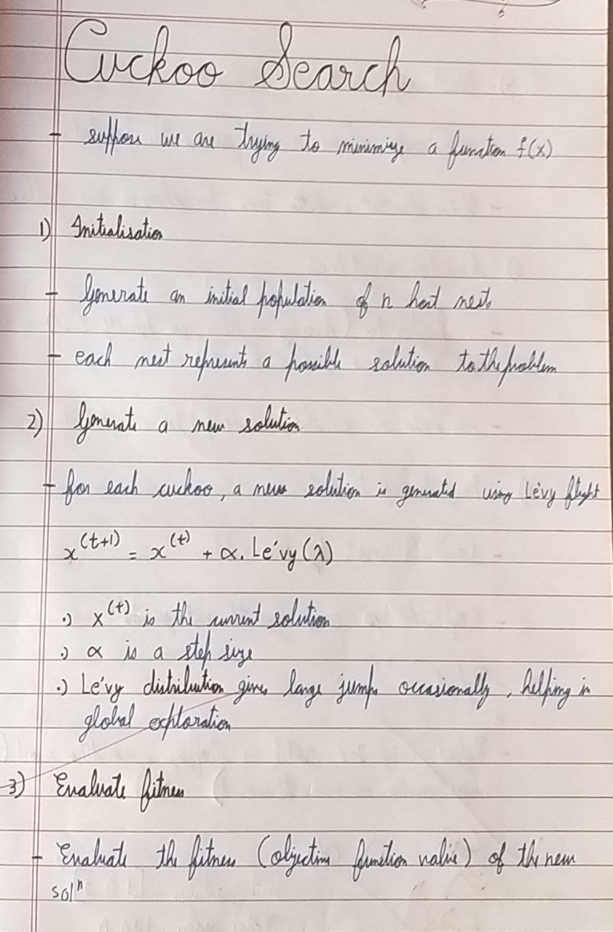

optimization problems and has applications in various domains, including engineering design,

machine learning, and data mining.

**Algorithm:**

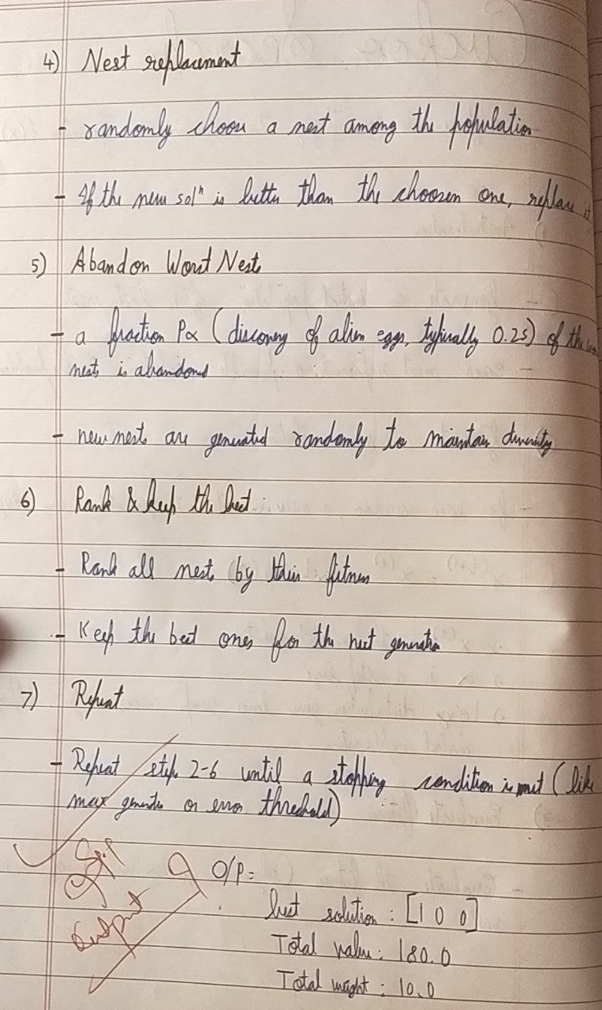

pa = 0.25

(math.gamma((1 + Lambda) / 2) * Lambda * 2 ** ((Lambda - 1) / 2))) ** (1 / Lambda)

sigma_u = (math.gamma(1 + Lambda) * math.sin(math.pi * Lambda / 2) /

def levy_flight(Lambda=1.5):

return [random.randint(0, 1) for _ in range(n_items)]

def generate_nest():

return total_value

else:

return 0 # Penalize overweight solutions

if total_weight > capacity:

total_value = sum(v for v, s in zip(values, solution) if s == 1)

total_weight = sum(w for w, s in zip(weights, solution) if s == 1)

def fitness(solution):

max_iter = 50

n_nests = 15

n_items = len(weights)

capacity = 100 # Max weight capacity of the truck

values = [60, 100, 120, 240, 80, 150, 200]

weights = [10, 20, 30, 40, 15, 25, 35]

import math

import random

**Code:**

best_solution, best_value = cuckoo_search()

fitness_values[i] = new_fitness

for i in range(n_nests):

if random.random() < pa:

nests[i] = generate_nest()

fitness_values[i] = fitness(nests[i])

current_best_index = fitness_values.index(max(fitness_values))

current_best_fitness = fitness_values[current_best_index]

if current_best_fitness > best_fitness:

best_fitness = current_best_fitness

best_nest = nests[current_best_index][:]

return best_nest, best_fitness

if __name__ == "__main__":

nests[i] = new_nest

total_weight = sum(w for w, s in zip(weights, best_solution) if s == 1)

print(f"Best packing solution (1 = selected): {best_solution}")

print(f"Total value of supplies packed: {best_value}")

print(f"Total weight: {total_weight}")

**Program 6 : Grey Wolf Optimization**

**Problem statement:**

The Grey Wolf Optimizer (GWO) algorithm is a swarm intelligence algorithm inspired by the social

hierarchy and hunting behavior of grey wolves. It mimics the leadership structure of alpha, beta,

return new_nest

u = random.gauss(0, sigma_u)

v = random.gauss(0, 1)

step = u / (abs(v) ** (1 / Lambda))

return step

def get_cuckoo(nest, best_nest):

new_nest = []

for xi, bi in zip(nest, best_nest):

step = levy_flight()

val = xi + step * (xi - bi)

s = 1 / (1 + math.exp(-val))

new_val = 1 if s > 0.5 else 0

new_nest.append(new_val)

def cuckoo_search():

nests = [generate_nest() for _ in range(n_nests)]

fitness_values = [fitness(nest) for nest in nests]

best_index = fitness_values.index(max(fitness_values))

best_nest = nests[best_index][:]

best_fitness = fitness_values[best_index]

for _ in range(max_iter):

for i in range(n_nests):

new_nest = get_cuckoo(nests[i], best_nest)

new_fitness = fitness(new_nest)

if new_fitness > fitness_values[i]:

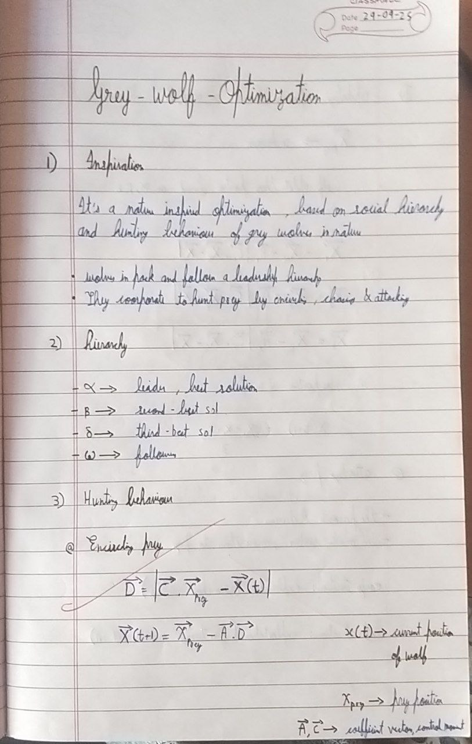

delta, and omega wolves and their collaborative hunting strategies. The GWO algorithm uses these

social hierarchies to model the optimization process, where the alpha wolves guide the search process

while beta and delta wolves assist in refining the search direction. This algorithm is effective for

continuous optimization problems and has applications in engineering, data analysis, and machine

learning.

**Algorithm:**

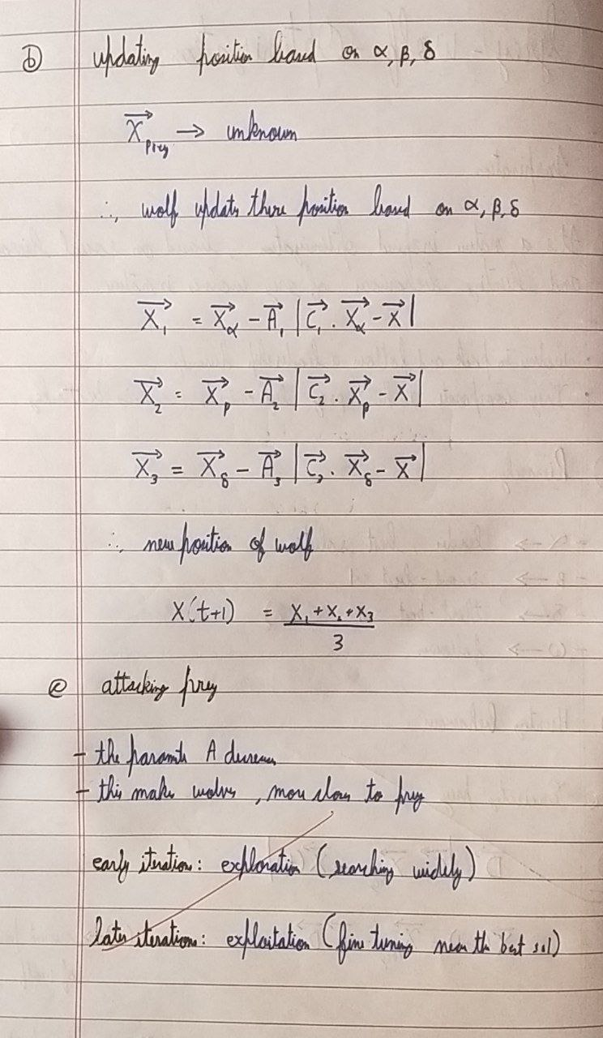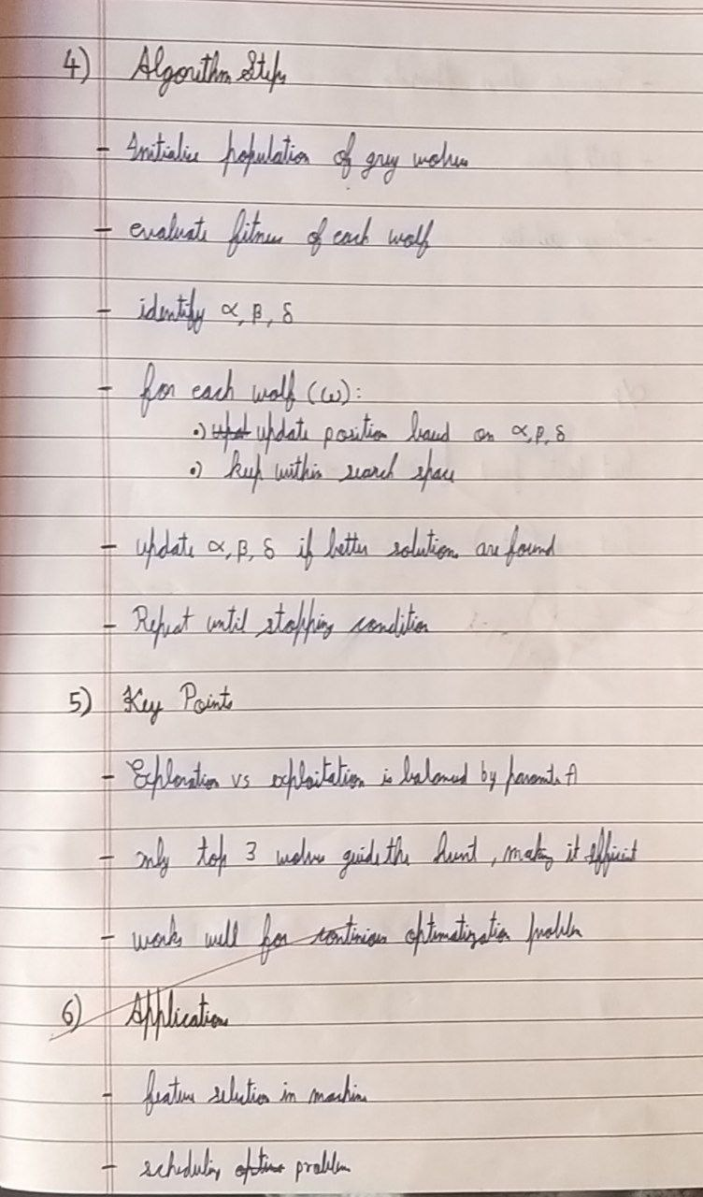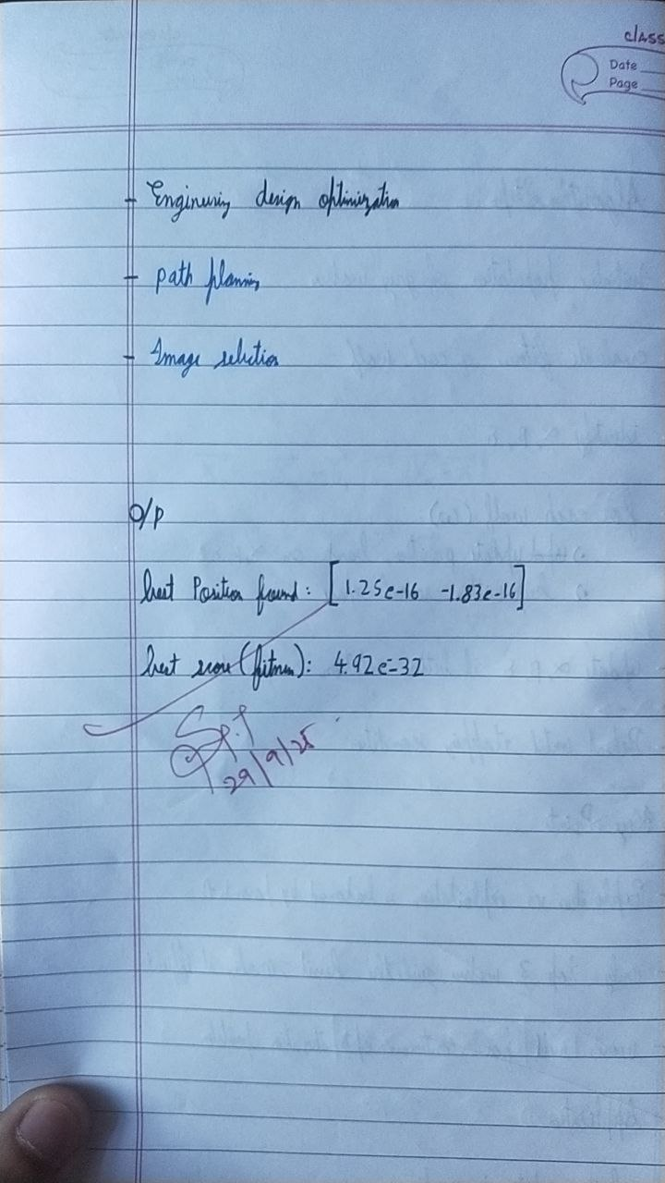

if fitness < alpha_score:

r1, r2 = np.random.rand(), np.random.rand()

for j in range(dim):

for i in range(n_agents):

a = 2 - 2 * (t / max_iter)

delta_score, delta = fitness, wolves[i].copy()

elif fitness < delta_score:

beta_score, beta = fitness, wolves[i].copy()

delta_score, delta = beta_score, beta

elif fitness < beta_score:

alpha_score, alpha = fitness, wolves[i].copy()

beta_score, beta = alpha_score, alpha

delta_score, delta = beta_score, beta

fitness = obj_func(wolves[i])

for i in range(n_agents):

for t in range(max_iter):

alpha_score, beta_score, delta_score = float("inf"), float("inf"), float("inf")

alpha, beta, delta = None, None, None

wolves = np.random.uniform(lb, ub, (n_agents, dim))

lb, ub = search_space

def gwo(obj_func, dim, search_space, n_agents=20, max_iter=100):

import numpy as np

**Code:**

for i in range(1, len(path) - 1):

if ox1 <= x <= ox2 and oy1 <= y <= oy2:

return True

return False

waypoints = waypoints.reshape(-1, 2)

path = [start] + [w.astype(int) for w in waypoints] + [goal]

total_dist, penalty = 0, 0

for i in range(len(path) - 1):

dist = np.linalg.norm(path[i + 1] - path[i])

total_dist += dist

if is_collision(path[i + 1]):

penalty += 100

energy = 0

for ox1, oy1, ox2, oy2 in obstacles:

v1 = path[i] - path[i - 1]

v2 = path[i + 1] - path[i]

if np.linalg.norm(v1) > 0 and np.linalg.norm(v2) > 0:

cos_angle = np.dot(v1, v2) / (np.linalg.norm(v1) * np.linalg.norm(v2))

angle = np.arccos(np.clip(cos_angle, -1, 1))

energy += angle

return total_dist + energy * 5 + penalty

n_waypoints = 5 # intermediate waypoints

dim = n_waypoints * 2

best_path, best_score = gwo(path_cost, dim, (0, grid_size[0]-1), n_agents=30, max_iter=200)

best_waypoints = best_path.reshape(-1, 2).astype(int)

return alpha, alpha_score

A1, C1 = 2 * a * r1 - a, 2 * r2

D_alpha = abs(C1 * alpha[j] - wolves[i][j])

X1 = alpha[j] - A1 * D_alpha

r1, r2 = np.random.rand(), np.random.rand()

A2, C2 = 2 * a * r1 - a, 2 * r2

D_beta = abs(C2 * beta[j] - wolves[i][j])

X2 = beta[j] - A2 * D_beta

r1, r2 = np.random.rand(), np.random.rand()

A3, C3 = 2 * a * r1 - a, 2 * r2

D_delta = abs(C3 * delta[j] - wolves[i][j])

X3 = delta[j] - A3 * D_delta

wolves[i][j] = np.clip((X1 + X2 + X3) / 3, lb, ub)

grid_size = (20, 20)

start, goal = np.array([0, 0]), np.array([19, 19])

obstacles = [

(5, 5, 10, 10),

(12, 0, 14, 14),

(3, 15, 15, 17)

]

def is_collision(point):

x, y = point.astype(int)

if x < 0 or y < 0 or x >= grid_size[0] or y >= grid_size[1]:

return True

**Algorithm:**

enhanced performance.

large-scale optimization problems and can be implemented on parallel computing architectures for

explore the search space effectively. Parallel Cellular Algorithms are particularly suitable for

interaction models the diffusion of information across the cellular grid, enabling the algorithm to

potential solution and interacts with its neighbors to update its state based on predefined rules. This

parallel computing to solve complex optimization problems efficiently. Each cell represents a

parallel and distributed manner. These algorithms leverage the principles of cellular automata and

Parallel Cellular Algorithms are inspired by the functioning of biological cells that operate in a highly

**Problem statement:**

**Program 7 : Parallel cellular Optimization**

print("\nPath Cost:", round(best_score, 2))

print(p)

for p in clean_path:

print("Best Path Found:")

clean_path.append(pt)

if len(clean_path) == 0 or pt != clean_path[-1]:

pt = tuple(map(int, p))

for p in final_path:

clean_path = []

final_path = np.vstack([start, best_waypoints, goal])

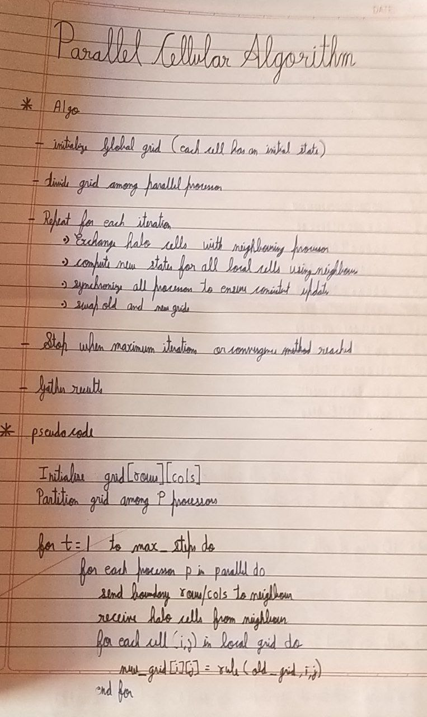

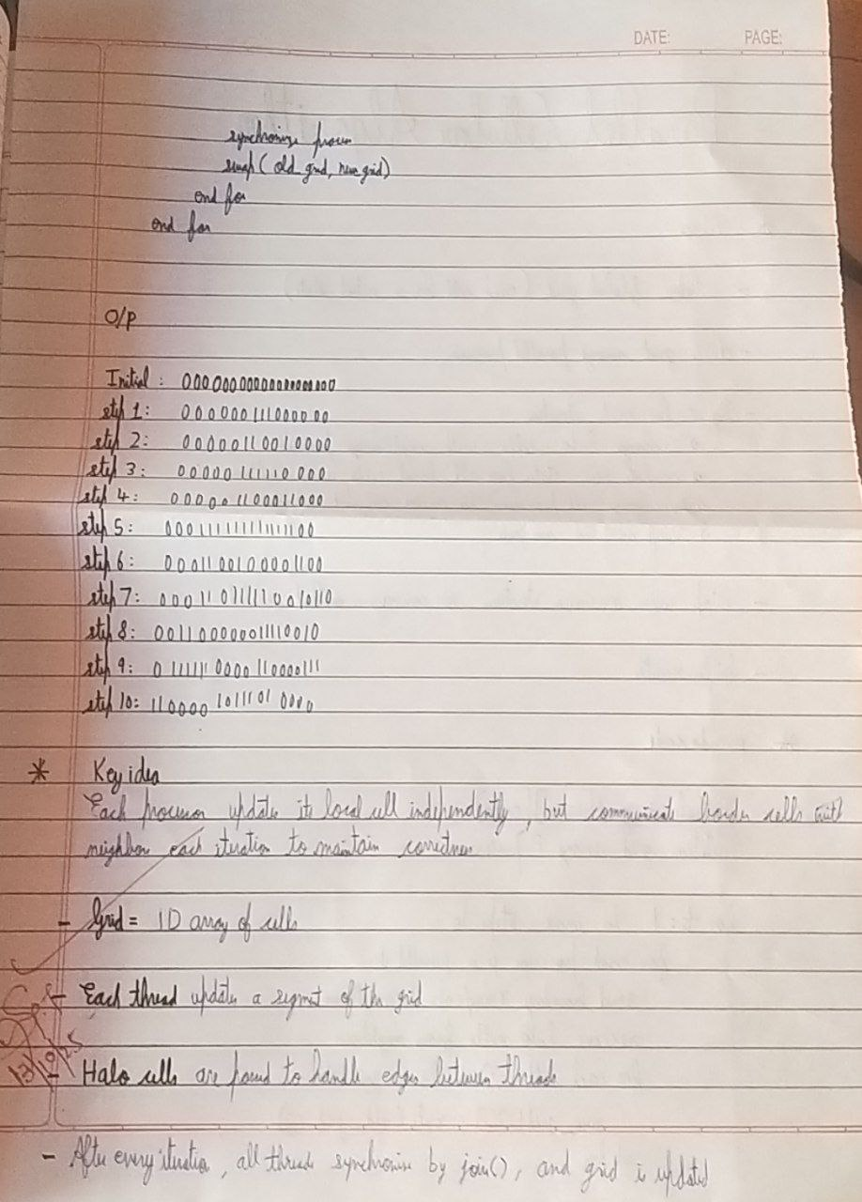

num_customers = distance_matrix.shape[0] - 1

for i in range(num_vehicles):

total_distance = 0

split_points = np.linspace(0, num_customers, num_vehicles + 1, dtype=int)

def fitness(individual):

population = [generate_individual() for _ in range(population_size)]

return perm

random.shuffle(perm)

perm = list(range(1, num_customers + 1))

def generate_individual():

num_vehicles = 2

grid_dim = (3, 3)

population_size = 9

])

[10, 4, 8, 0]

[9, 6, 0, 8],

[2, 0, 6, 4],

[0, 2, 9, 10],

distance_matrix = np.array([

from itertools import permutations

import random

import numpy as np

**Code:**

parent1 = pop[idx]

child[pointer] = gene

pointer += 1

return child

def mutate(individual):

a, b = random.sample(range(len(individual)), 2)

individual[a], individual[b] = individual[b], individual[a]

return individual

def pca_iteration(pop):

new_pop = pop.copy()

for idx in range(len(pop)):

neighbors = get_neighbors(idx)

partner_idx = random.choice(neighbors)

pointer = 0

parent2 = pop[partner_idx]

child = crossover(parent1, parent2)

if random.random() < 0.2:

child = mutate(child)

if fitness(child) < fitness(pop[idx]):

new_pop[idx] = child

return new_pop

num_generations = 25

for gen in range(num_generations):

population = pca_iteration(population)

best_fitness = min(fitness(ind) for ind in population)

if n_idx != idx:

route = [0] + individual[split_points[i]:split_points[i+1]] + [0] # depot at start and end

for j in range(len(route) - 1):

total_distance += distance_matrix[route[j], route[j+1]]

return total_distance

def get_neighbors(idx):

r, c = divmod(idx, grid_dim[1])

neighbors = []

for dr in [-1, 0, 1]:

for dc in [-1, 0, 1]:

nr, nc = r + dr, c + dc

if 0 <= nr < grid_dim[0] and 0 <= nc < grid_dim[1]:

n_idx = nr * grid_dim[1] + nc

neighbors.append(n_idx)

return neighbors

def crossover(parent1, parent2):

size = len(parent1)

a, b = sorted(random.sample(range(size), 2))

child = [None] * size

child[a:b] = parent1[a:b]

pointer = b

for gene in parent2[b:] + parent2[:b]:

if gene not in child:

if pointer == size:

print(f"Generation {gen+1}: Best total distance = {best_fitness}")

best_individual = min(population, key=fitness)

print("\nBest route assignment (split evenly):")

split_points = np.linspace(0, num_customers, num_vehicles + 1, dtype=int)

for i in range(num_vehicles):

route = [0] + best_individual[split_points[i]:split_points[i+1]] + [0]

print(f"Vehicle {i+1} route: {route}")

print(f"Total distance: {fitness(best_individual)}")